**PART 4: Building the Report**

*For the final phase of the project, you can either follow the instructions to recreate the report shown below, or design your own version -- the choice is yours!*

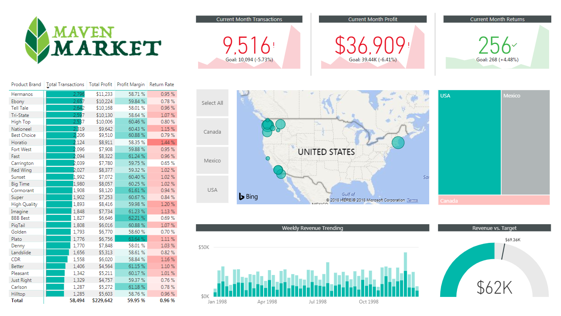

**1)** Rename the tab "**Topline Performance**" and insert the Maven Market logo

**2)** Insert a **Matrix** visual to show **Total Transactions**, **Total Profit**, **Profit Margin**, and **Return Rate** by **Product_Brand**(*on rows*)

* Add conditional formatting to show **data bars** on the Total Transactions column, and **color scales** on Profit Margin (*White to Green*) and Return Rate (*White to Red*)
* Add a visual level**Top N** filter to only show the top 30 product brands, then sort descending by Total Transactions

**3)**Add a **KPI Card** to show **Total Transactions**, with **Start of Month** as the trend axis and **Last Month Transactions** as the target goal

* Update the title to "***Current Month Transactions***", and format as you see fit
* Create two more copies: one for **Total Profit**(*vs. Last month Profit*) and one for **Total Returns** (*vs. Last Month Returns*)
  + Make sure to update titles, and change the Returns chart to color coding to "*Low is Good*"

**4)**Add a **Map** visual to show **Total Transactions** by store city

* Add a slicer for store country
  + Under the "selection controls" menu in the formatting pane, activate the "***Show Select All***" option
  + **Pro Tip:** Change the orientation in the "General" formatting menu to**horizontal** and resize to create a *vertical*stack (rather than a list)

**5)** Next to the map, add a **Treemap** visual to break down **Total Transactions** by store country

* Pull in **store_state** and **store_city**beneath **store_country** in the "Group" field to enable drill-up and drill-down functionality

**6)** Beneath the map, add a **Column Chart** to show **Total Revenue** by week, and format as you see fit

* Add a **report level filter** to only show data for 1998
* Update the title to "***Weekly Revenue Trending***"

**7)** In the lower right, add a **Gauge Chart** to show **Total Revenue** against**Revenue Target**(*as either "target value" or "maximum value"*)

* Add a visual level **Top N** filter to show the latest **Start of Month**
* Remove data labels, and update the title to "***Revenue vs. Target***"

**8)**Select the Matrix and activate the  **Edit interactions** option to prevent the Treemap from filtering

**9)** Select "*USA"* in the country slicer, and drill down to select "*Portland*" in the Treemap

* Add a new bookmark named "***Portland 1000 Sales***"
* Add a new report page, named "***Notes***"
* Insert a text box and write something along the lines of "***Portland hits 1,000 sales in December***"
* Add a button (your choice) and use the "***Action***" properties to link it to the bookmark you created
* Test the bookmark by CTRL-clicking the button
* Find 2-3 additional insights from the Topline Performance tab and add new bookmarks and notes linking back

**10)** Get creative! Practice creating new visuals, pages, or bookmarks to continue exploring the data!